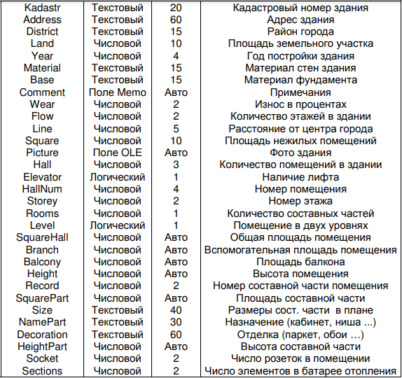

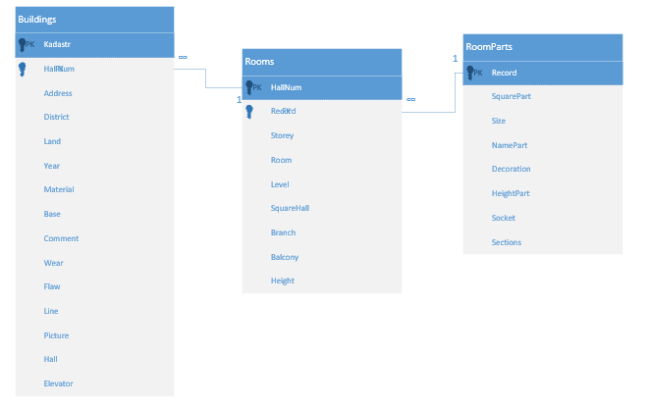

Create table Rooms

(

HallNum float(4)

CONSTRAINT PK2 PRIMARY KEY (HallNum),

Record float(2)

CONSTRAINT FK1 FOREIGN KEY (Record) REFERENCES Rooms_Parts (Record),

Storey float(2),

Room float(1),

SquareHall float null,

Branch float null,

Balcony float null,

Height float null,

Level bit

)

Create table Rooms_Parts

(

Record float(2)

CONSTRAINT PK3 PRIMARY KEY (Record),

SquarePart float null,

Size varchar(40),

NamePart varchar(30),

Decoration varchar(60),

HeightPart float null,

Socket float (2),

Sections float (2)

)

Create table Buildings

(

Kadastr varchar (50)

CONSTRAINT PK1 PRIMARY KEY (Kadastr),

HallNum float(4)

CONSTRAINT FK2 FOREIGN KEY (HallNum) REFERENCES Rooms (HallNum),

Storey float(2),

Address varchar (50),

District varchar (15),

Land float (10) ,

Years float(4),

Material varchar (15),

Base varchar (15),

Comment varchar null,

Wear float(2),

Flow float(2),

Line float(2),

square float(2),

picture image,

Hall float(3),

Elevator bit

)